Call Center Optimization & Investment Strategy

Problem Statement:

AstroSage has received a ₹1 crore investment to improve its call center operations. The goal is to analyse historical call data, performance metrics, and market trends to determine how best to allocate this investment. The objective is to enhance operational efficiency, customer satisfaction, and profitability through data driven decisions on staffing, technology, training, and process improvements.

PREPARED BY: P.SUNNYHITHA
Data Description:
The dataset contains detailed records of customer interactions with astrologers through call and chat-based consultation services. Each record represents a single customer session and captures user information, session characteristics, consultation type, financial transactions, timestamps, and satisfaction-related attributes. This data is used to understand call center performance, customer behavior, operational workload, and revenue contribution.

The dataset includes the following types of information:

- Basic Session Identification
These fields uniquely identify each record:
  - _id – Unique identifier for each session.
  - uid – Numeric user identifier.
  - gid – Numeric astrologer identifier.

- User Information
- user – Alphanumeric identifier assigned to the customer.
- region – Geographical region of the user.
- website – Platform used for the consultation (e.g., App, Dashboard, GuruCool).

- Astrologer Information
  - guruName – Astrologer’s display name.
  - gid – Astrologer ID in numeric format.

- Consultation Details
  - consultationType – Type of consultation (Chat or Call).
  - website – Platform used (e.g. GuruCool, etc.).
  - FreeCall – Indicates if the call was free (true/false).
  - FreeChat – Indicates if the chat was free (true/false).
  - queue – Indicates whether the session was queued.

- Chat Specific Fields
  - chatStatus – Status of the chat (Incomplete, Failed,etc).
  - chatStartTime – Timestamp when the chat began.
  - chatEndTime – Timestamp when the chat ended.
  - chatSeconds – Total duration of the chat in seconds.
  - timeDuration – Additional duration field related to chat timing.

- Call Specific Fields
  - callChannel – Channel used for call communication.
  - callIvrType – IVR type used during the call.
  - callStatus – Status of the call (Connected, Failed, Missed, Busy, etc.).
  - userCallStatus – User-side call connection status.
  - astrologerCallStatus – Astrologer-side call connection status.
  - userOnCallDuration – Duration of the call from the user's side.
  - astrologerOnCallDuration – Duration of the call from the astrologer’s side.

- Timestamp Fields

- CreatedAT – Date and time when the session was created.
- UpdatedAt – Date and time of last update to the session.
- Date / Month / Year / Month-Year / Hour – Derived fields used for trend analysis.

- Financial Information
- amount – Amount paid by the user for the session.
- astrologersEarnings – Amount paid to the astrologer.
- netAmount – Final revenue retained by AstroSage.
- RefundStatus – Refund eligibility or status

- Customer Satisfaction

  - rating – User’s rating for the session.

Tasks:

Objective Questions:

- What is the total no. of tables present in the data?

Ans:
The dataset consists of a single(1) structured table containing customer session records. The cleaned dataset used for analysis is derived from this raw table through preprocessing and standardization.

2. What is the total no. of attributes present in the data?

Ans:
The raw dataset contains a total of 35 attributes (columns). After data cleaning and preprocessing, 32 attributes were retained for analysis. Additional derived fields such as Date, Month, Year, Hour, and Month-Year were created to support time-based analysis.

- The data consists of some inconsistent and missing values so ensure that the data used for further analysis is cleaned.

Ans:
The dataset was cleaned to remove inconsistencies, standardize formats, and make it suitable for further analysis. The following preprocessing steps were applied:

Step 1: Removed duplicates

- Checked _id field to identify duplicate records
- Removed repeated entries from the raw dataset

Step 2: Standardized date and time formats

- Converted createdAT, chatStartTime, and chatEndTime into proper datetime format
- Derived the following time-based fields: Date, Month, Year, Hour, Month_Year

Step 3: Handled missing and null values

- Filled or replaced missing categorical values using N/A where appropriate
- Retained zero durations for failed/incomplete calls since they carry meaningful status information

Step 4: Cleaned textual fields

- Applied TRIM and PROPER to remove extra spaces and standardize case
- Unified category labels in fields such as consultationType and website

Step 5: Converted numeric fields

- Converted financial and duration columns to numeric data types:
amount, netAmount, astrologersEarnings, userOnCallDuration, astrologerOnCallDuration, chatseconds

Step 6: Added derived financial and operational fields

- Ensured netAmount reflects platform revenue
- After cleaning, the resulting dataset used for pivots and dashboard generation contained 32 attributes suitable for analysis.

- What is the change in daily call volume day by day and also find the average daily call volume.

Ans:

- A Pivot Table was created with Date in rows.
- Count of consultationType was used as the value field.
- Consultation Type is used in filter field with only calls.
- This showed how call volume changes day by day.
- The AVERAGE function was applied on daily call counts to get the average.

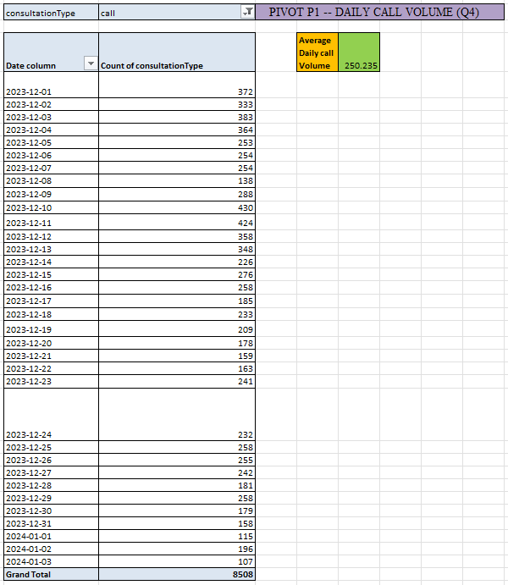

Average Daily Call Volume: 824 calls/day

- Which months experienced the highest and lowest callVolumes?

Ans:
- A Pivot Table was created with Month_Year in rows.
- Count of Consultation Type was used as the value field.
- And consultation type – calls is used in Filter field
- The pivot showed variation in call volume across months.
- The highest and lowest months were identified from the pivot output.
Highest Call Volume: December [ 8090 calls ]
Lowest Call Volume: January [ 418 calls ]

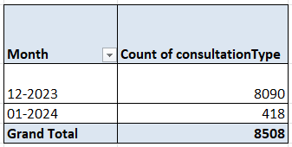

- What is the total operational cost for that month?

Ans:

- A Pivot Table was created with Month_Year in rows.
- Sum of operational_cost was used in values.
- This showed the total operational cost incurred each month.
Highest Operational Cost: December - ₹ 93786
Lowest Operational Cost: January - ₹ 5,360

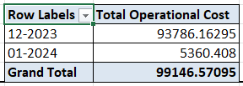

- What is the average number of calls handled per agent per day?

Ans:
- A Pivot Table was created with Days in rows and Guru (agent) in columns.
- Count of calls was used as the value field.
- Additional calculations were performed to compute:
- Total Days = 34
- Total Calls = 10,344
- Unique Agents = 148
- The average was calculated using:
Average Calls per Agent per Day = Total Calls / (Agents × Days)
Average Calls per Agent per Day: ≈ 2 calls/agent/day

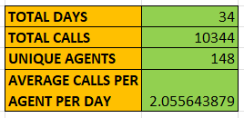

- How many repeat callers are there, and what percentage of total calls do they represent?

Ans:

- A Pivot Table was created on uid to count call frequency.
- Users with more than one call were treated as repeat callers.
- Calculations performed:
- Total Repeat Callers: 1272
- Calls by Repeat Callers: 6156
- Total Calls: 8508
- Repeat Calls %: 72.36%

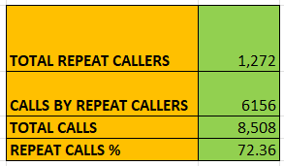

- What are the total sales generated by the call centre for each product category?

Ans:

- A Pivot Table was created using consultationType as rows and sum of amount as values.
- Free calls and free chats were excluded by applying filters.
- The pivot displays total sales generated for each product category.

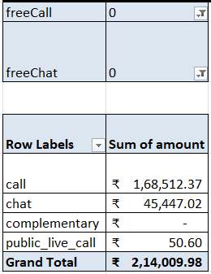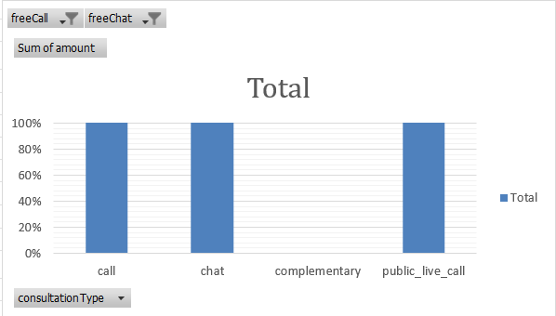

Call-based consultations generated the highest sales, followed by chat
consultations, while public live calls contributed minimally to overall revenue.

- How many calls were made for each user ID and guru ID?

ANS:

- A Pivot Table was created using uid in rows and count of calls in values to calculate calls per user ID.
- A separate Pivot Table was created using gid (or guruName) in rows and count of calls in values to calculate calls per guru ID.
- This provides a clear distribution of call volume by users and by gurus.

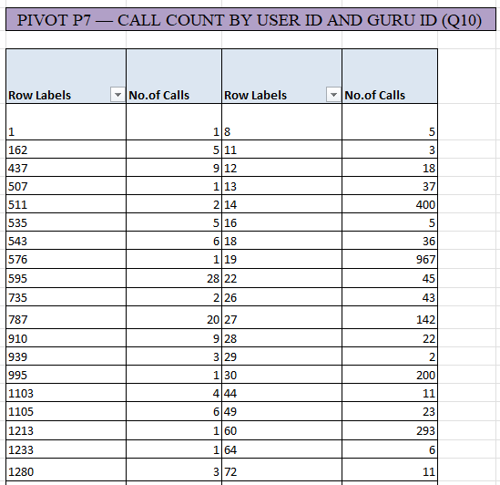

Counting… in the excel sheet in pivot section as Q10.

- What is the correlation between call duration and customer satisfaction?

Ans:
- Call records were filtered to include only valid calls with userOnCallDuration greater than 0 and rating greater than 0.
- A helper table was created with userOnCallDuration and rating.
- The correlation between call duration and customer satisfaction was calculated using the CORREL function.

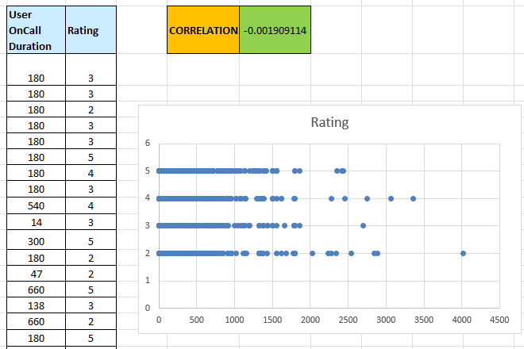

- Which guru has the highest and lowest customer satisfaction scores?

Ans:
- A Pivot Table was created using guruName in rows and Average of rating in values.
- Only valid ratings were considered, and the pivot was sorted based on average rating.
- From the pivot, the highest and lowest average satisfaction scores were identified.

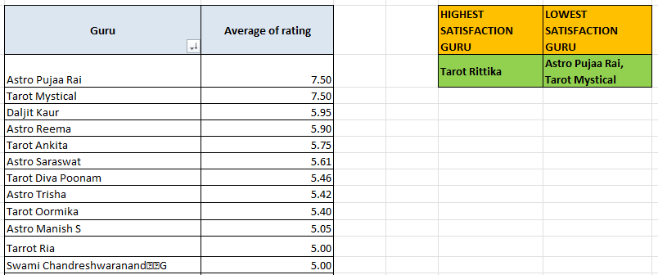

- What is the average customer satisfaction score by month?

Ans:

- A Pivot Table was created using Month_Year in rows and Average of rating in values.
- Only valid customer ratings were included by excluding zero or missing values.
- The pivot shows the average customer satisfaction score for each month.
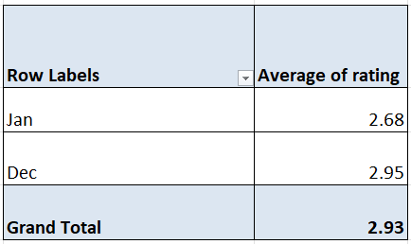

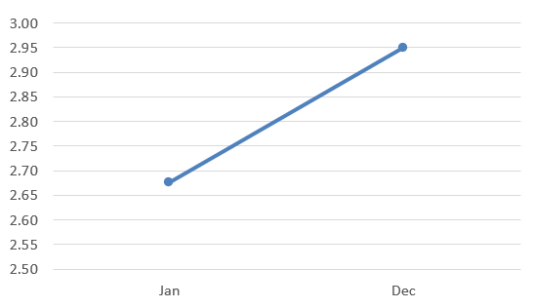

- How many categorical columns are there in the data?

Ans: There are 15 categorical columns.

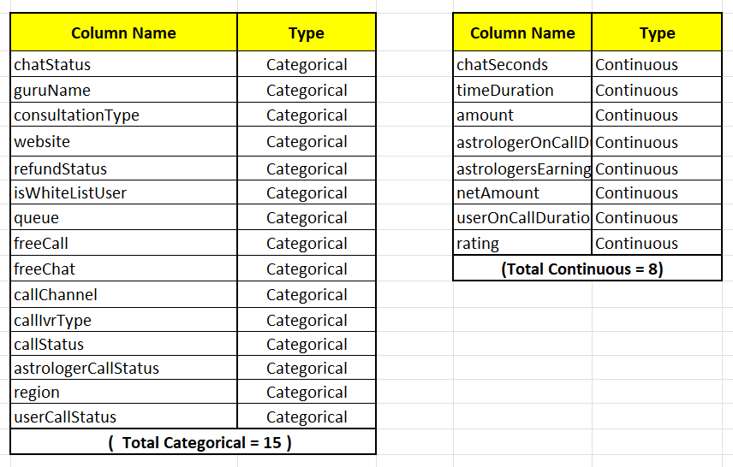
Subjective Questions:

Should the investment be used to hire more agents, improve training programs, or upgrade call center technology?

To determine the most effective use of investment, the analysis evaluated agent performance, service efficiency, and system reliability using pivot tables and visualizations derived from the cleaned dataset.

- Hiring More Agents (Based on Guru-wise Performance Analysis)

To evaluate whether additional agents are required, guru-level performance was analyzed using average customer ratings per guru.

A Pivot Table was created with:
- Rows: guruName
- Values:
  - Average of rating
  - Count of rating (number of consultations)
Key Observations:
- Average ratings across gurus show significant variation, ranging from approximately below 2 to above 6.
- A large number of gurus have average ratings clustered around the mid-range, while only a few consistently achieve higher ratings.
- Certain gurus handle a very high volume of consultations, whereas others handle comparatively fewer sessions.
Insight:

The uneven distribution of both ratings and consultation volume indicates variability in service quality and workload concentration among gurus. High consultation loads on certain gurus may contribute to inconsistent customer experiences.

Conclusion:

To reduce workload pressure on heavily engaged gurus and improve overall service consistency, a portion of the investment should be allocated to selective hiring of additional agents, particularly to balance consultation distribution during high-demand periods.additional agents, particularly to balance consultation distributionduring high-demand periods. 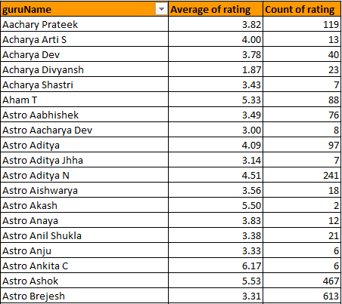

B. Improve Training Program (Based on Average Call Time and Ratings)

To assess the effectiveness of existing training and communication practices, call consultations were analyzed using average call duration and average rating for each guru.

A Pivot Table was created using with:
- Rows: g_id
- Values:
    - Average of userOnCallDuration
    - Average of rating
- Filter: consultationType = Call

Key Observations:
- Average call duration varies widely across gurus, with some calls being significantly longer than others.Average ratings also vary widely, from as low as 1.0 to above 5.5.
- Average ratings do not consistently increase with longer call durations.
- Several gurus record longer call durations but relatively moderate or low ratings, while others achieve better ratings with shorter or optimal call lengths.

Insight:

Longer call durations do not necessarily translate into higher customer satisfaction.
This mismatch suggests potential gaps in communication efficiency, problem
resolution skills, or structured consultation handling.

Conclusion:

Investment in targeted training programs is required to enhance call efficiency, communication clarity, and service consistency. Focused training for underperforming gurus can improve customer satisfaction without increasing call duration.

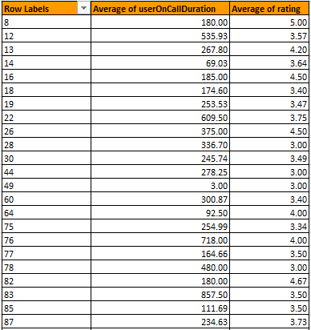

C. Upgrade Call Center Technology (Based on Call vs Chat Status
Comparison)

To evaluate system reliability, call and chat consultation outcomes were compared using status distributions.

i) Call Status Distribution:

Call consultation statuses were analyzed to assess the performance of the current call infrastructure.
Key Observations:

- Out of 8,508 call consultations, only about 40% were completed successfully.
- A significant proportion of calls fall under busy, no-answer, failed, or incomplete categories.
This indicates that a majority of call attempts do not result in successful consultations.

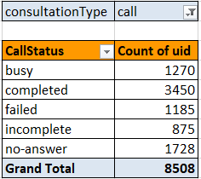

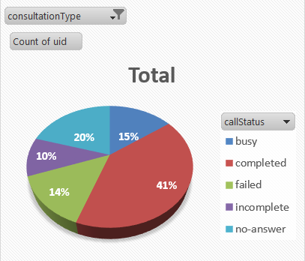
ii)Chat Status Distribution (Chat Distribution):

- Chat consultation statuses were analyzed to compare system stability with call consultations.

Key Observations:
- Chat consultations show a higher proportion of completed sessions.
- Failures are comparatively fewer than in call consultations.

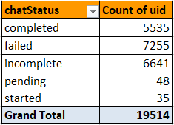

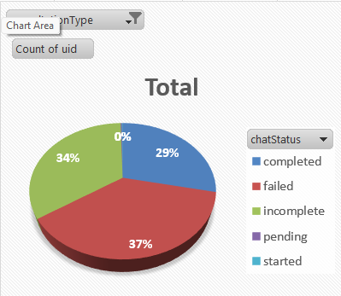

Insight:

Call consultations experience significantly higher failure rates compared to chat consultations, indicating limitations in call infrastructure during peak traffic periods.

Conclusion:
Investment should prioritize upgrading call center technology to reduce call failures and improve overall system reliability.

Final Recommendation Based on the Analysis

- Call center technology upgrades should be prioritized to address low call completion rates.
- Structured training programs should be implemented to improve service efficiency and customer satisfaction.
- Selective hiring of additional agents during peak periods can further reduce workload imbalance and improve service quality.

2. What are the potential risks of each investment option (hiring, training, technology upgrades), and how can they be mitigated?
Name the chart/spreadsheet function you will use for solving the problem.

Ans:

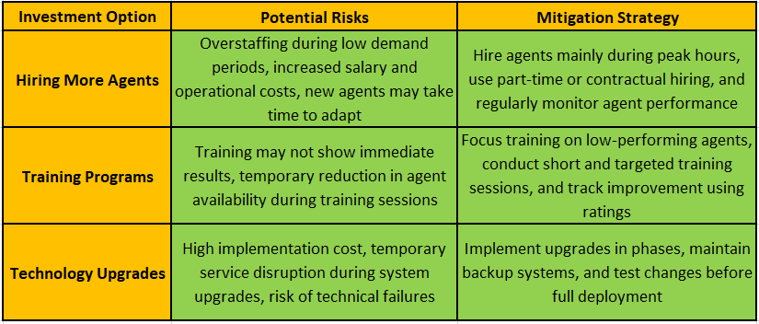

Explanation:
Each investment option carries certain risks, but these risks can be effectively controlled with proper planning. Hiring should be demand-based, training should be focused and time-efficient, and technology upgrades should be gradual and well-tested to avoid service disruptions.

3. How does AstroSage's call center performance compare to AstroGuru's average call volume, customer satisfaction, and agent performance? Will you use any aggregation function or a visualization here to solve the problem?

Ans:
To compare AstroSage’s call center performance with AstroGuru-style service outcomes, the analysis evaluated call volume trends, call completion efficiency, customer satisfaction, and agent performance using pivot tables, aggregation functions, and visualizations derived from the cleaned dataset.

1: Call Volume Analysis:
To understand the workload handled by AstroSage’s call center, daily call
volumes were analyzed using the consultation creation date.

A Pivot Table was created using createdAT (grouped by Date) as rows,
with count of consultations as values, considering only call consultations.

Key Observations:

- The call center handled a total of 8,508 call consultations.
- Calls were distributed across 34 active days, resulting in an average of approximately 250 calls per day.
- The highest daily call volume was 430 calls (10-Dec), while the lowest was 107 calls (03-Jan).
- Multiple days recorded 300+ calls, indicating consistently high demand.

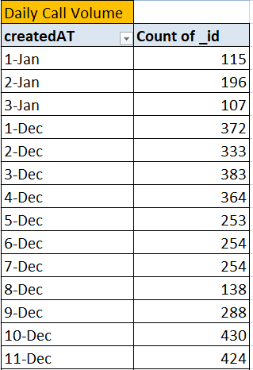

Insight:
AstroSage’s call center experiences sustained and high call demand, comparable to large-scale astrology platforms such as AstroGuru.
2: Call Completion Performance:

Out of 8,508 total calls, only 3,450 calls were completed successfully, resulting in a call completion rate of 40.55%.

The remaining 59.45% (5,058 calls) were unsuccessful due to:
- Busy: 1,270
- No-answer: 1,728
- Failed: 1,185
- Incomplete: 875

Compared to an efficient call center setup, this completion rate is low and directly impacts service effectiveness.

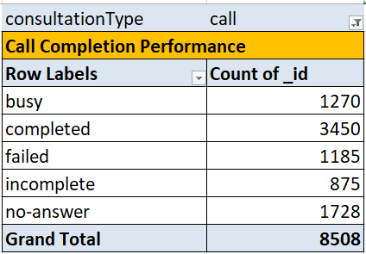

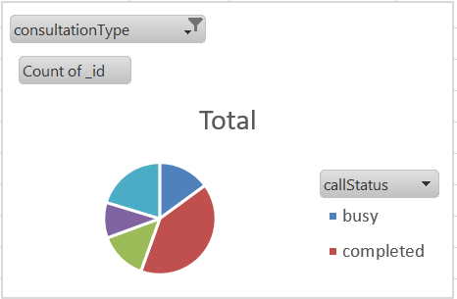

3: Customer Satisfaction Comparison:

Average customer ratings by consultation type show:

- Call: 3.50
- Chat: 2.69
- Complementary: 4.50
- Public live call: 3.00
- Overall average rating: 2.93
Although call consultations have higher ratings than chat, overall satisfaction remains moderate, influenced by high call failure rates.

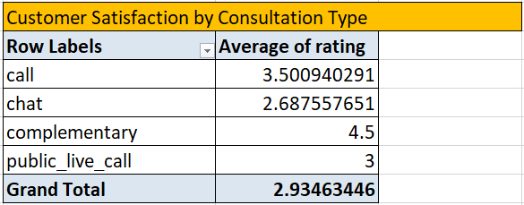

4: Revenue Contribution Analysis:

Revenue analysis shows that:

- Call consultations generated ₹1,68,442.04, contributing 78.7% of total revenue
- Chat consultations generated ₹45,494.68 (21.3%)
Total net revenue: ₹2,13,987.32

This confirms that calls are the primary revenue source, making call center performance critical for business success.

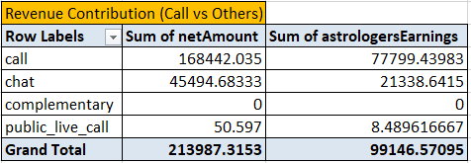
5: Relationship Between Agent Earnings and Company Income:

The relationship between astrologers’ earnings and company income was analyzed using the CORREL function.
The correlation value obtained is 0.99998988, indicating a very strong positive relationship between agent earnings and company revenue. This shows that as agent performance improves, the company’s income also increases almost proportionally.

=CORREL(range of astrologers_earnings, range of net_amount)
=0.995

4. How can the call center improve its handling of peak call periods to ensure high customer satisfaction?
Mention the functionality you will use for giving the suggestions, will it be any aggregated function or a visualization?

Functionality Used
To provide data-driven suggestions, aggregated functions (COUNT) were used through Pivot Tables, along with bar and column chart visualizations to identify peak call periods and system pressure.
Daily Call Analysis
The daily call volume analysis shows that 10th December and 11th December recorded the highest number of calls, with 430 and 424 calls respectively, indicating peak demand days.
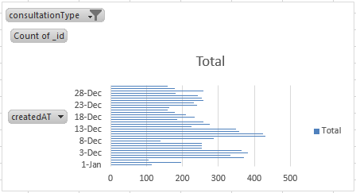
Call Completion Analysis on Peak Days

During these peak periods, a significant number of calls were marked as busy, failed, incomplete, or no-answer, indicating system overload.

Out of a total of 8,508 calls:
- 3,450 calls were completed
- Completion Percentage = 40.55%

This shows that more than half of the calls were unsuccessful, reflecting
heavy pressure on call center resources during peak periods.

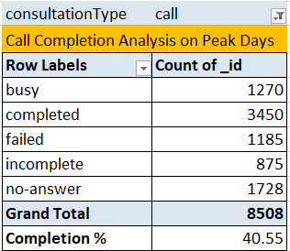

Hourly Call Distribution

The hourly call distribution further shows that calls peak during morning and afternoon hours, particularly between 6 AM and 5 PM, with the highest call volumes observed around 7–9 AM and 3–4 PM.

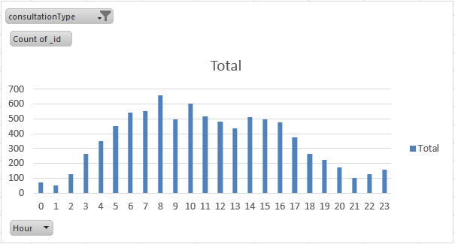

Hourly Call distribution which shows the peak hours
Actions Based on Analysis:
Based on the identified peak days and hours, the call center can take the following actions:
- Assign more agents during peak hours identified from the hourly call data
- Plan shift timings based on peak call days and time slots
- Hire or allocate additional agents specifically for high-demand periods
- Improve call routing and agent availability to reduce busy and no-answer cases
Conclusion:

By using aggregated functions like COUNT through Pivot Tables and visualizations such as bar and column charts, peak call periods can be clearly identified. This enables better workforce planning, reduces call failures, and ultimately improves customer satisfaction during high-demand periods.

5. Based on historical data, what strategic initiatives should be prioritized to improve efficiency and customer satisfaction?

Ans:

Approach Used
Historical data was analyzed using Pivot Tables with aggregated functions such as COUNT and AVERAGE, along with bar and column chart visualizations, to identify operational inefficiencies and customer satisfaction gaps.

Strategic Initiatives:

1. Upgrade Call Center Technology:
Call status analysis shows that out of 8,508 total calls, only 3,450 calls were completed, while the remaining calls resulted in busy (1,270), failed (1,185), incomplete (875), and no-answer (1,728) statuses, indicating system overload.

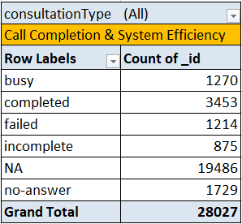
Initiative:

Upgrade call routing, load balancing, and queue management systems. Introduce automated handling for basic queries to reduce congestion and improve call completion rates.

  - Improve Training Programs for Gurus:

The average customer rating across consultation types is 2.93, indicating low overall customer satisfaction. Call consultations (3.50) and Chat consultations (2.69) have lower ratings compared to Complimentary consultations (4.5), highlighting service quality gaps.

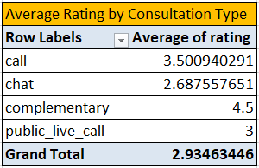

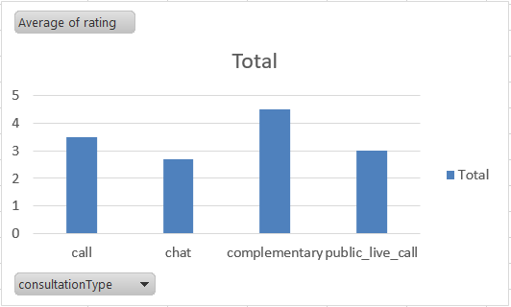

Initiative:
Implement structured training programs focused on communication skills, service consistency, and faster issue resolution for lower-rated consultation types.
  - Focus on High-Impact Platforms and Services:

Platform-wise analysis shows that GuruCool has the lowest average rating (2.72) compared to App (3.5) and Dashboard (4.5), indicating a critical customer experience gap on a high-usage platform.

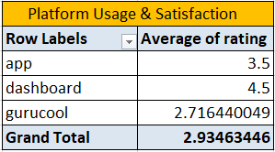

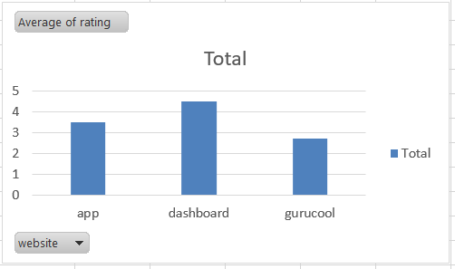

Initiative:

Improve user experience on the GuruCool platform by optimizing interface performance and reducing technical issues. Apply best practices from higher-rated platforms to improve satisfaction in high-impact channels.

4.Optimize Agent Capacity During Peak Hours:

Hourly call volume analysis shows peak activity between 6 AM and 5 PM, with the highest call volume of 698 calls around 9 AM, contributing to increased busy and no-answer cases.
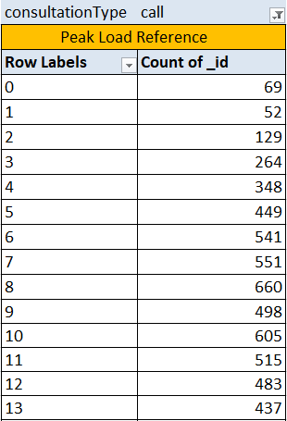
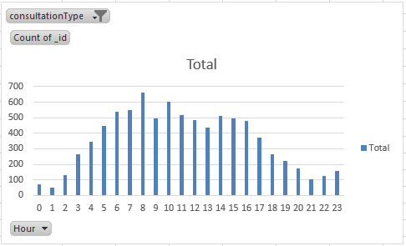

Initiative:
Implement shift-based scheduling and allocate additional agents during peak hours to evenly distribute workload and improve call completion rates.

Conclusion

By using aggregated functions such as COUNT and AVERAGE through Pivot Tables, supported by bar and column chart visualizations, key operational inefficiencies and customer satisfaction gaps were clearly identified. Prioritizing call center upgrades, targeted guru training, platform optimization, and peak-hour workforce planning will significantly improve efficiency and customer satisfaction.

6. What can be the key factors contributing to high customer satisfaction scores, and how can these be leveraged to improve overall performance? What is the basis for the suggestions? And mention how you decided if the satisfaction score affects the ratings.

Ans:

Approach Used:

To identify the key factors influencing customer satisfaction, the analysis was carried out using Pivot Tables with AVERAGE and COUNT aggregations, comparing customer ratings across call duration, website/source, and consultation type. Satisfaction was measured using average user ratings, and patterns were observed across these dimensions.

A. Call Duration vs Ratings:

The overall average call duration is 35.45 minutes, with an average rating of 2.93. Gurus with moderate call durations generally receive higher ratings (above 3.5), while extremely long or very short calls do not consistently result in higher ratings.
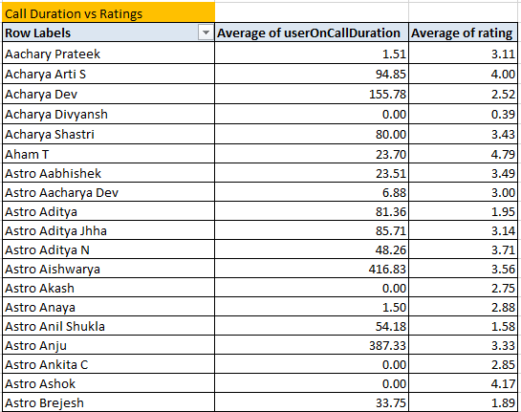

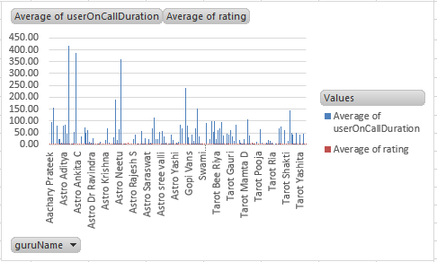

Insight:

Longer call duration alone does not guarantee higher satisfaction. Interaction quality and clarity have a stronger impact than duration.

B. Website / Source vs Ratings:

Platform-wise analysis shows that the App has a higher average rating (3.5) compared to GuruCool, which has the lowest average rating (2.72) despite handling the highest user volume (20,225 users).

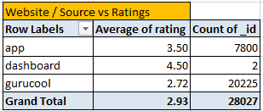

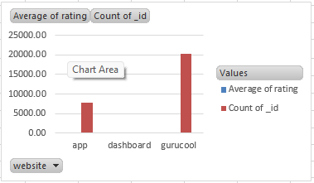
Insight:
Platform usability and experience significantly influence customer satisfaction. High usage with low ratings highlights priority areas for improvement.
C. Consultation Type vs Ratings:

Consultation-type analysis shows that Complimentary consultations receive the highest average rating (4.5), while Chat consultations have the lowest average rating (2.69). Call consultations (3.50) perform better than chat but still show scope for improvement.

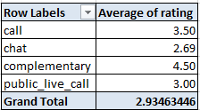

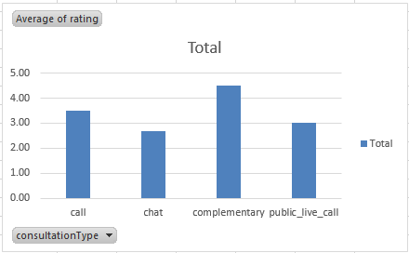

Insight:

Interaction richness and engagement level affect satisfaction, with live or voice-based consultations performing better than chat.

Conclusion & Recommendations

Customer satisfaction is primarily influenced by interaction quality, platform experience, and consultation type, rather than call duration alone. Since higher satisfaction scores directly translate into higher ratings, focusing on improving GuruCool usability, enhancing chat consultation quality, and adopting best practices from high-rated consultation types will significantly improve overall performance and customer satisfaction.

7. How should the call center balance the workload among agents to ensure optimal performance and avoid burnout?
Mention your approach and spreadsheet function for the answer.

Ans:

Approach Used:

To analyze workload imbalance among agents (Astro Gurus), Pivot Tables were used with aggregated spreadsheet functions such as COUNT and AVERAGE. The analysis focused on:
- Number of calls handled by each guru
- Average calls per guru as a benchmark
- Hour-wise call distribution to identify peak-time pressure

A. Identifying Workload Imbalance Across Gurus:

Key Observations:
- Total call records analyzed: 8,508
- A small number of gurus handled extremely high call volumes, for example:
- Astro Shalini – 1,060
- Tarot Gauri – 497 calls
- Astro Brijesh – 342 calls
- Dr Balkrisna – 309 calls
- Tarot Gurpreet – 300 calls
- Astro Divya – 271 calls
- Tarot Rupika – 225 calls
- At the same time, a large number of gurus handled very few calls, with many handling between 1 and 10 calls only.

Insight:

The workload is heavily skewed, with a small group of gurus handling a disproportionately large number of calls, while many others remain significantly underutilized.

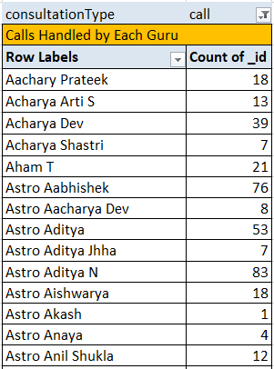

B. Benchmarking Average Calls per Guru:

To establish a fair workload benchmark:
- Total Calls (Call only): 8,508
- Total Astro Gurus: 131

Average Calls per Guru:
8508 /128 = 66.47 ≈ 66 calls per guru

Interpretation:
- Gurus handling more than 66 calls are considered overloaded
- Gurus handling fewer than 66 calls are considered underutilized

Insight:

The benchmark confirms that workload distribution is uneven, increasing burnout risk for high-load gurus and inefficient utilization of available resources.

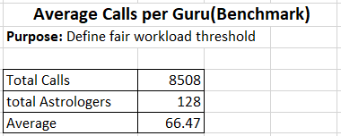

C. Peak Hour Pressure Analysis:

Key Findings:

- Call volumes rise significantly during daytime hours.
- Peak pressure hours include:
- Hour 8 – 660 calls
- Hour 10 – 605 calls
- Hour 7 – 551 calls
- Hour 11 – 515 calls
- Hour 14 – 513 calls

Insights:

Peak-hour demand amplifies workload imbalance, repeatedly overloading the same high-performing gurus during high-demand periods.

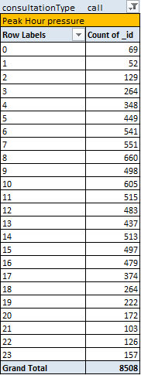

Final Insights:
- Workload is unevenly distributed across gurus
- A small group of gurus consistently exceed the average workload benchmark
- Peak-hour pressure intensifies burnout risk and impacts service quality

Recommendations:
- Smart Call Routing:
Distribute calls based on current guru workload instead of only availability
- Shift-Based Scheduling:
Allocate more agents during peak hours
- Workload Rotation:
Balance call assignments across underutilized gurus
- Chatbot & Automation Support:
Reduce call volume by handling basic queries automatically
- Regular Monitoring:
Track weekly call loads to prevent long-term overload

Conclusion:

By using COUNT-based Pivot Tables to analyze calls handled by each guru, AVERAGE functions to benchmark fair workload, and hour-wise analysis to identify peak-time pressure, workload imbalance was clearly identified. Implementing smarter routing, optimized scheduling, and automation will help evenly distribute workload, reduce burnout, and maintain consistent service quality.

- What new technologies or tools could be implemented to enhance call center operations and customer service?

Ans:

  - IVR + improved telephony / carrier fixes: Reduces failed/incomplete calls.
  - AI-based auto-routing (skills & load-based): Routes to available, skilled gurus to reduce wait & balance load.
  - Callback / virtual queue system: Lets customers keep place in line without holding. Reduces abandon.
  - Workforce Management (WFM) tool: Shift planning and shrinkage handling for peaks.
  - Call recording + speech analytics (NLP: Auto-detects bad calls, sentiment, QA. • Real-time dashboard + alerting (Power BI / Excel + Power Query): Ops visibility.
  - Chatbot / NLP assistant: Handles common queries, reduces simple load on gurus.
  - CRM integration: Context on repeat users to personalise calls.
  - Quality monitoring & coaching platform: Targeted training using real examples.
  - Payment & refund automation: Reduces disputes that lower rating.

- What metrics should be included in the final dashboard to comprehensively view call center performance and guide investment decisions?

Ans:

To gain a complete view of call center performance and support informed investment decisions, the final dashboard should include a combination of operational, customer, agent, time-based, and financial metrics.

Key Metrics to Include:

- Key Performance Indicators (KPIs):
  - Total Revenue – ₹2,13,987.32
  - Total Days – 34
  - Total Calls – 8,508
  - Total Chats – 19,514
  - Total Gurus – 148
  - Average Rating – 2.93
  - Average Calls per Agent – 57

These KPIs provide an instant snapshot of business scale, efficiency, and service quality.

2.Time-Based Metrics:
- Hourly Call Distribution
- Day-Wise Call Volume

These metrics identify peak hours and high-demand days, enabling
efficient workforce planning and shift allocation.

3.Service & Usage Metrics:
- Category-wise Revenue (Call vs Chat vs others)
- Website-wise Distribution (App, Dashboard, GuruCool)
- Chat Status Distribution
- Call Status Distribution

These indicators highlight demand patterns, platform performance, and operational bottlenecks.

4.Customer Experience Metrics:
- User Rating Distribution
- Rating-wise Guru DistributioAverage Rating
- Average Rating

These metrics measure satisfaction levels and service quality consistency across agents and platforms.

5. Agent Performance Metrics:
- Top 10 Gurus by Calls Handled
- Average Calls per Agent

These help identify high performers, overloaded agents, and workload
imbalance for staffing decisions.

6. Filters and Controls
The dashboard includes interactive slicers for:
- Consultation Type
- Year
- Website
These allow decision-makers to dynamically explore trends across time,platform and service type.
Conclusion:

By integrating operational, performance, customer satisfaction, agent workload,
and revenue metrics into a single interactive dashboard, decision-makers gain a comprehensive view of call center performance. This enables data-driven investment decisions related to staffing, training, platform improvements, and operational optimization.

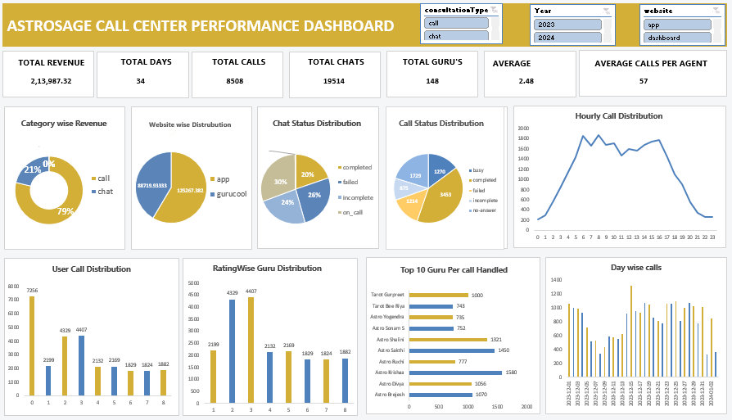

10. How would you allocate a 1 crore rupee investment to optimize operational efficiency, enhance customer satisfaction, and boost profitability, and what analysis-based recommendations would you offer to support this?

Ans:

  - 30% – Technology & Infrastructure Enhancement (₹30 lakhs)
- Upgrade backend systems to reduce busy, failed, and no-answer calls observed in call status analysis.
- Improve platform performance, especially for high-usage sources like GuruCool.
- Implement intelligent call routing and automated handling for basic queries.
- This investment is justified because dashboard analysis shows uneven call handling and system pressure during peak hours.

  - 25% – Workforce Expansion & Load Balancing (₹25 lakhs)
- Hire additional agents to reduce workload imbalance, as dashboard shows several gurus handling extremely high call volumes while others handle very few.
- Introduce shift-based scheduling based on hourly call distribution.
- Implement workload rotation to prevent agent burnout.
- This is supported by analysis showing average calls per agent is 57 but several exceed this significantly.
3. 20% – Training & Quality Improvement (₹20 lakhs)
- Provide targeted training to low-performing gurus identified from rating distribution.
- Conduct communication and consultation effectiveness workshops.
- Establish performance monitoring programs to ensure service consistency.
- This is justified because average rating is only 2.93, indicating customer satisfaction gaps.

4. 15% – Customer Experience Optimization (₹15 lakhs)
- Improve booking flow and reduce waiting time using queue optimization.
- Implement structured feedback analysis to identify dissatisfaction patterns.
- Introduce loyalty incentives for repeat users.
- Dashboard rating trends indicate many users provide mid-range ratings, showing potential for improvement.

5. 10% – Revenue Growth & Marketing Strategy (₹10 lakhs)
- Promote high-revenue consultation categories identified in revenue charts.
- Run targeted campaigns during low-call days to stabilize demand.
- Offer bundled consultation packages to increase revenue per user.
- This is supported by category-wise revenue analysis showing uneven revenue distribution across services.

Analysis-Based Recommendations:
- Call volume charts show peak-hour pressure, justifying investment in staffing and scheduling.
- Guru-wise call distribution confirms workload imbalance, requiring load balancing.
- Rating analysis reveals service quality gaps, supporting training investment.
- Platform-wise metrics indicate performance differences, validating technology upgrades.
- Revenue charts highlight profitable services that should be prioritized for growth.

Conclusion:
The investment plan strategically distributes ₹1 crore across technology, workforce, training, customer experience, and revenue growth initiatives. Each allocation directly addresses operational inefficiencies, satisfaction gaps, and profitability opportunities identified through dashboard analysis. This data-driven allocation ensures balanced improvement in efficiency, service quality, and business performance, leading to sustainable growth of the call center.

